Marks Processing Lab Exercise

Objective
To understand how to manage, store, and process student marks data using different data structures in C++, transitioning from basic scalar variables to Object-Oriented Programming (OOP) concepts.

Part 1: Scalar Data (Single Student, Multiple Subjects)
Goal: Learn how to handle individual data points using basic variables.
Write a C++ program that processes the marks of a single student for three subjects (Math, Science, and English) using scalar variables.
- Requirements:
  - Prompt the user to enter the student's name.
  - Prompt the user to enter marks for the three individual subjects.
  - Calculate the Total Marks and the Average Mark.
  - Display the student's name, individual marks, total, and average.

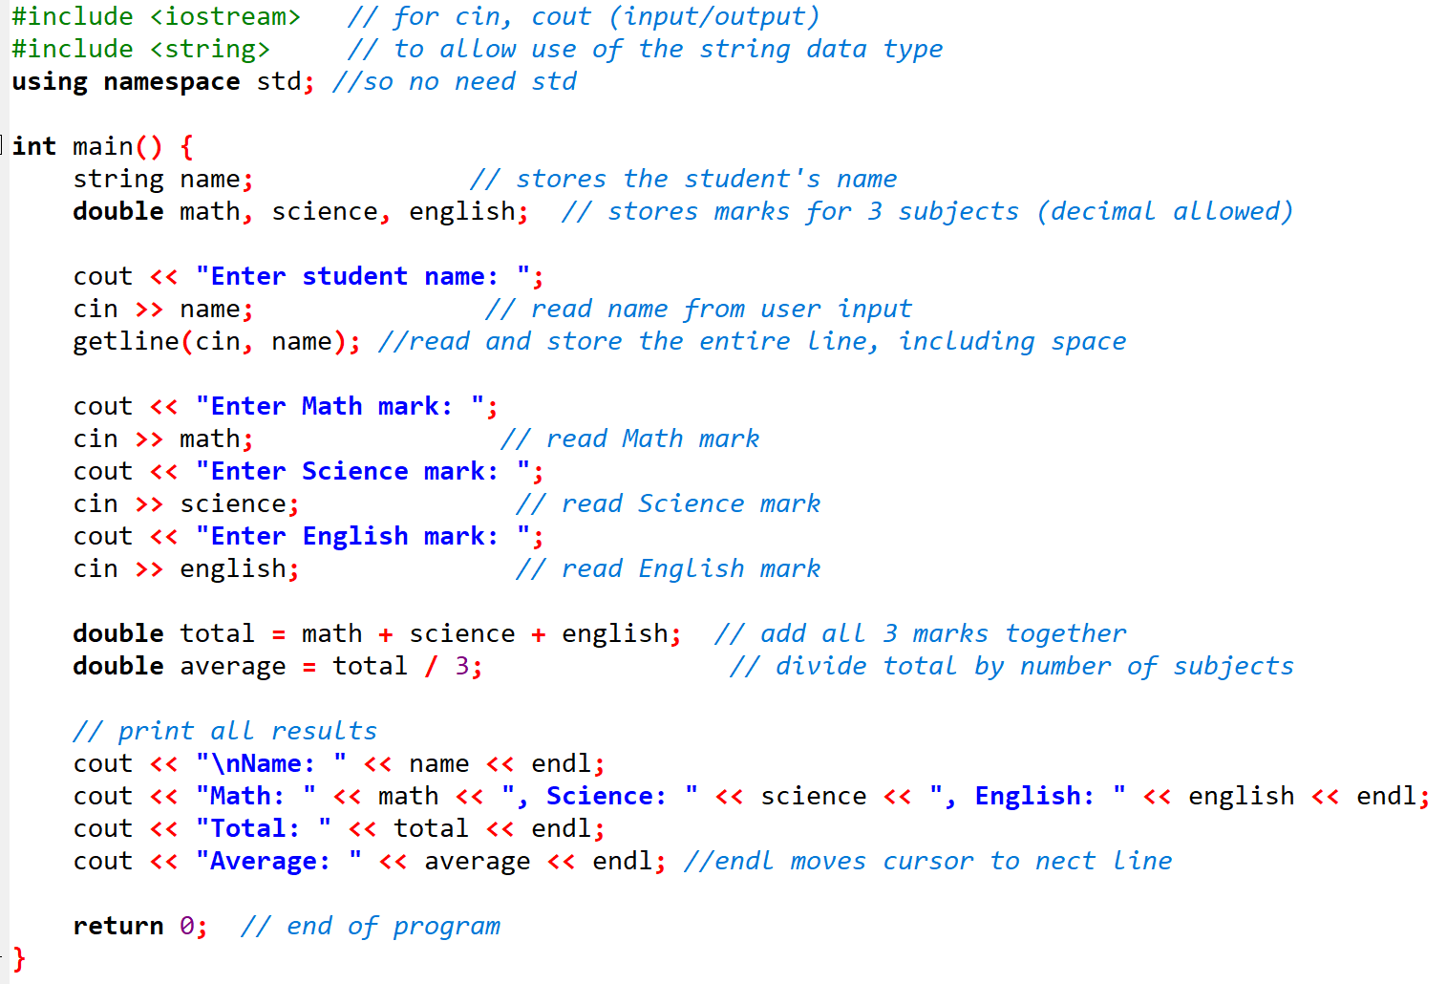

Part 2: Array Data (Multiple Students, Multiple Subjects)
Goal: Scale the solution to handle multiple students using 1D and 2D arrays.
Modify the program to handle three students, each taking three subjects. Use a 1D array for names and a 2D array for marks.
- Requirements:
  - Use std::string names[3] to store names.
  - Use a 2D array double marks[3][3] where rows represent students and columns represent subjects.
  - Use nested loops to input data and to calculate/display the total and average for each student.

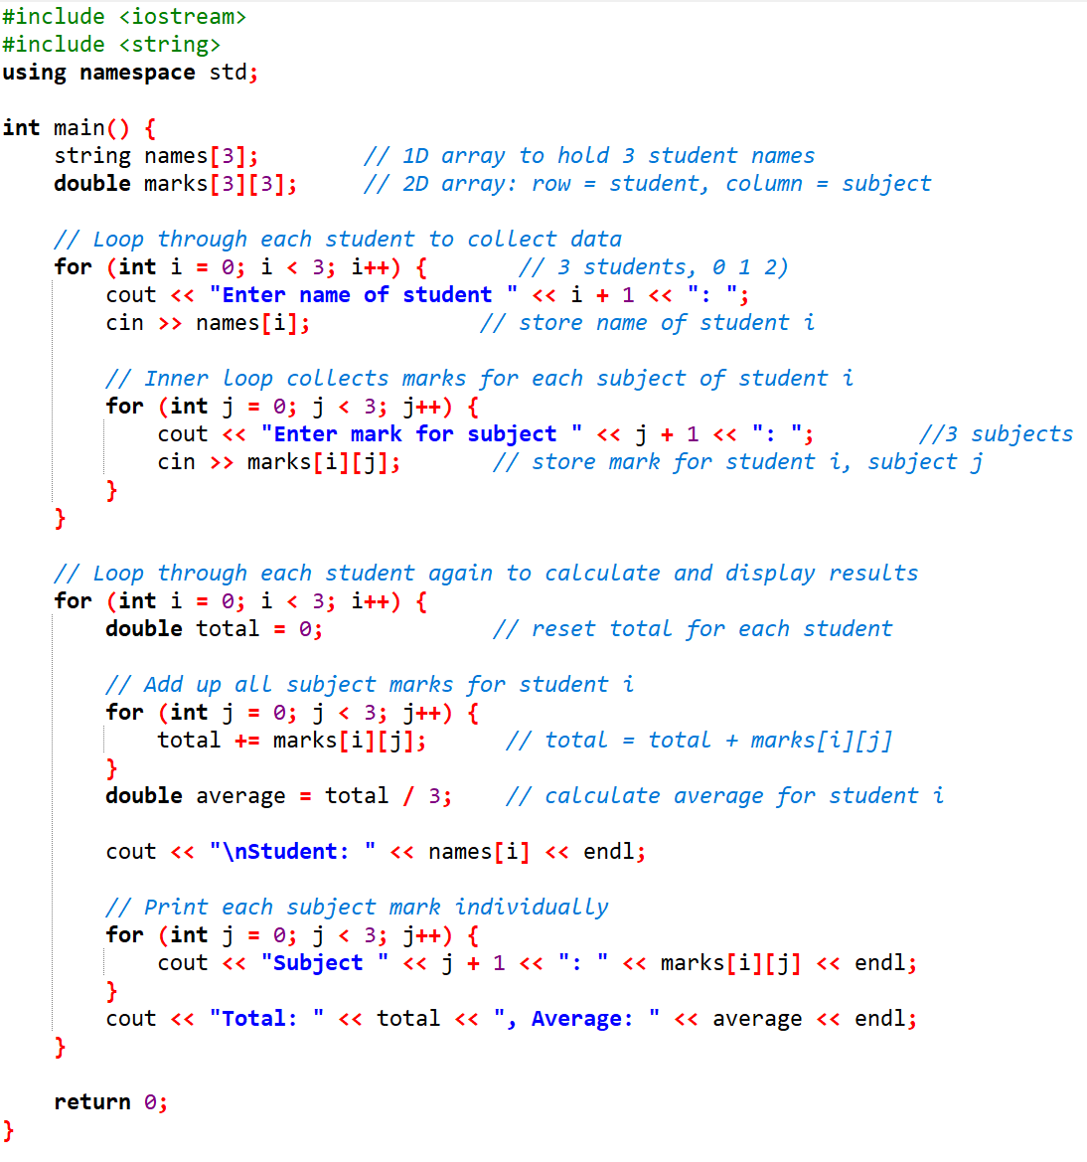

Part 3: Class with Array of Marks (Single Student, Multiple Subjects)
Goal: Introduce encapsulation by binding a student's data and behavior together using a Class.
Create a Student class that manages one student's details and an array of marks.
- Requirements:
  - Attributes (Private): std::string name, double marks[3].
  - Methods (Public): * inputData() to read the name and 3 marks.
    - calculateTotal() and calculateAverage() to compute metrics.
    - displayReport() to print the final scorecard.

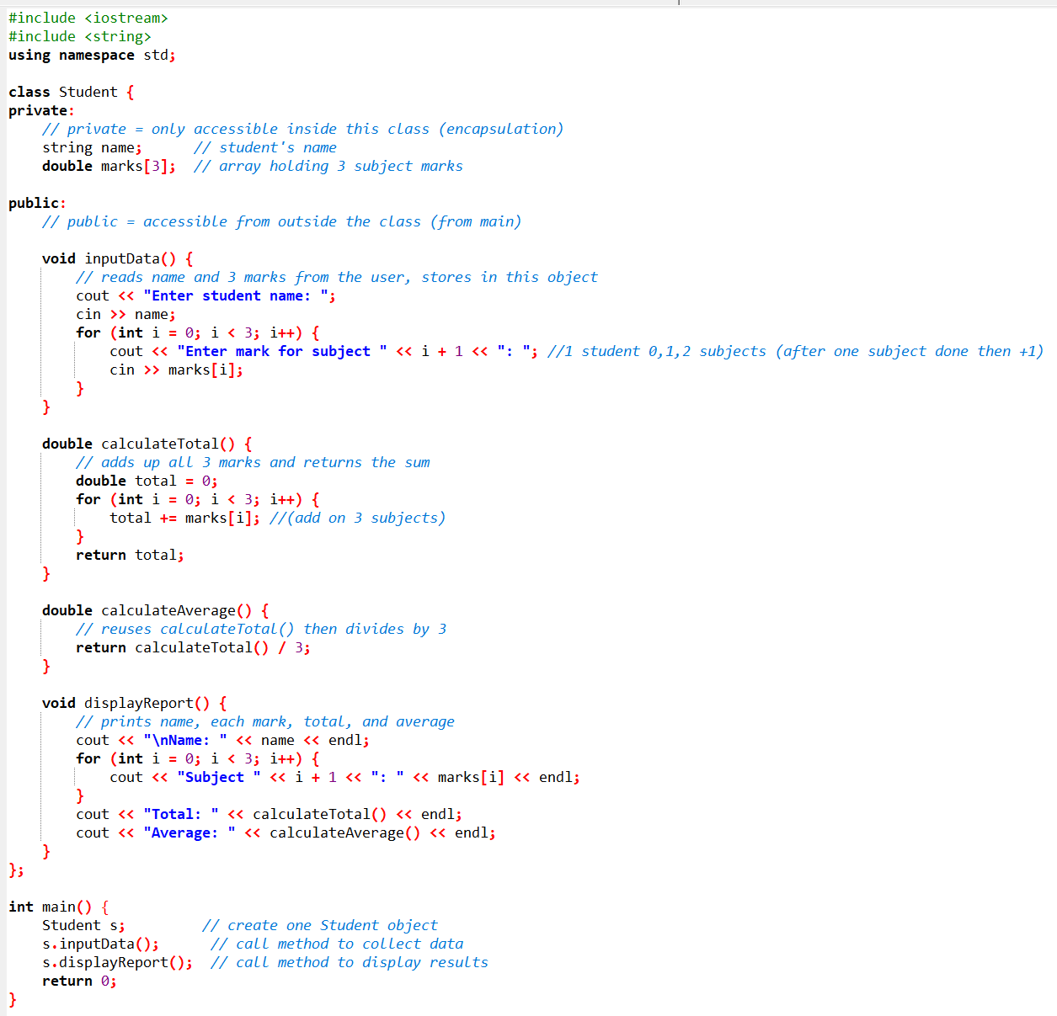

Part 4: Class with Array of Objects (Multiple Students, Multiple Subjects)
Goal: Combine OOP and arrays to build a complete, scalable database structure.
Using the Student class defined in Part 3, write a program that creates an array of Student objects to manage a whole classroom.
- Requirements:
  - Instantiate an array of Student objects (e.g., Student classroom[3]).
  - Loop through the array to call inputData() for each student.
  - Loop through the array to call displayReport() to print the final classroom roster.

